
A Project Report
on
SPELL CHECKER

Submitted in partial fulfilment of requirements for the award of the course
of
CGB1122 – DATA STRUCTURES

Under the guidance of

Mrs. S. RAMYA, M.E., Ph.D.,

Assistant Professor/AI

Submitted By

PRIYADHARSHINI S (927624BAD075)

DEPARTMENT OF FRESHMAN ENGINEERING

M.KUMARASAMY COLLEGE OF ENGINEERING
(Autonomous)
KARUR – 639 113
MAY 2025

M. KUMARASAMY COLLEGE OF ENGINEERING
(Autonomous Institution affiliated to Anna University, Chennai)

KARUR – 639 113

BONAFIDE CERTIFICATE

Certified that this project report on “SPELL CHECKER” is the bonafide work of PRIYADHARSHINI S (927624BAD075) who carried out the project work during the academic year 2024- 2025 under my supervision.

Signature | Signature
Mrs. S. RAMYA, M.E., Ph.D., | Dr. K.CHITIRAKALA, M.Sc., M.Phil.,Ph.D.,
SUPERVISOR, | HEAD OF THE DEPARTMENT,
Department of Artificial Intelligence, | Department of Freshman Engineering,
M. Kumarasamy College of Engineering, | M. Kumarasamy College of Engineering,
Thalavapalayam, Karur -639 113. | Thalavapalayam, Karur -639 113.

Submitted for the End Semester Review held on __________________________
DEPARTMENT OF ARTIFICIAL INTELLIGENCE AND DATA SCIENCE

VISION OF THE INSTITUTION
To emerge as a leader among the top institutions in the field of technical education
MISSION OF THE INSTITUTION
- Produce smart technocrats with empirical knowledge who can surmount the global challenges
- Create a diverse, fully-engaged, learner-centric campus environment to provide quality education to the students
- Maintain mutually beneficial partnerships with our alumni, industry, and Professional associations
VISION OF THE DEPARTMENT
To produce competent industry relevant education, skillful research, technical and innovative computer science professionals acquaintance with managerial skills, human and social values.
MISSION OF THE DEPARTMENT
- To impart technical knowledge through innovative teaching, research, and consultancy.
- To develop and to promote student ability thereby to compete globally through excellence in education.
- To facilitate the development of academic-industry Collaboration.
- To produce competent engineers with professional ethics, technical competence and a spirit of innovation and managerial skills.
PROGRAM EDUCATIONAL OBJECTIVES (PEOs)
PEO 1: To acquire technical knowledge and proficiency required for the employment and higher education in the contemporary areas of computer science or management studies.
PEO 2: To apply their competency in design and development of innovative solutions for real-world problems.
PEO 3: To demonstrate leadership qualities with high ethical standards and collaborated with other industries for the socio-economical growth of the country.
PROGRAM OUTCOMES (POs)
Engineering students will be able to:
- Engineering knowledge: Apply the knowledge of mathematics, science, engineering fundamentals, and an engineering specialization to the solution of complex engineering problems.
- Problem analysis: Identify, formulate, review research literature, and analyze complex engineering problems reaching substantiated conclusions using first principles of mathematics, natural sciences, and engineering sciences.
- Design/development of solutions: Design solutions for complex engineering problems and design system components or processes that meet the specified needs with appropriate consideration for the public health and safety, and the cultural, societal, and environmental considerations.
- Conduct investigations of complex problems: Use research-based knowledge and research methods including design of experiments, analysis and interpretation of data, and synthesis of the information to provide valid conclusions.
- Modern tool usage: Create, select, and apply appropriate techniques, resources, and modern engineering and IT tools including prediction and modeling to complex engineering activities with an understanding of the limitations.
- The engineer and society: Apply reasoning informed by the contextual knowledge to assess societal, health, safety, legal and cultural issues and the consequent responsibilities relevant to the professional engineering practice.
- Environment and sustainability: Understand the impact of the professional engineering solutions in societal and environmental contexts, and demonstrate the knowledge of, and need for sustainable development.
- Ethics: Apply ethical principles and commit to professional ethics and responsibilities and norms of the engineering practice.
- Individual and team work: Function effectively as an individual, and as a member or leader in diverse teams, and in multidisciplinary settings.
- Communication: Communicate effectively on complex engineering activities with the engineering community and with society at large, such as, being able to comprehend and write effective reports and design documentation, make effective presentations, and give and receive clear instructions.

- Project management and finance: Demonstrate knowledge and understanding of the engineering and management principles and apply these to one’s own work, as a member and leader in a team, to manage projects and in multidisciplinary environments.
- Life-long learning: Recognize the need for, and have the preparation and ability to engage in independent and life-long learning in the broadest context of technological change.

PROGRAM SPECIFIC OUTCOMES (PSOs)
- PSO1: Ability to apply the analytical and business skills to provide sustainable solutions as an engineer/researcher for the real-time applications using Machine Learning, Internet of Things and Data analytics.
- PSO2: Ability to practice ethical and human values with soft-skills qualities in computer science and business disciplines to emerge as an entrepreneur for the growth and development of the society.

ABSTRACT

This project introduces a comprehensive phone directory application designed for efficient contact management, implemented using a doubly linked list data structure. The application enables users to seamlessly add, update, and delete contacts, providing a dynamic and user-friendly interface. Leveraging the advantages of a doubly linked list, the system ensures swift insertion, deletion, and bidirectional traversal, accommodating the evolving nature of contact lists. Exception handling mechanisms enhance the robustness of the application, addressing unforeseen errors and ensuring stability. The user interface is intuitively designed, allowing users to display, search, edit, and delete contacts effortlessly. The project showcases technical proficiency in data structure implementation, emphasizing the significance of user-centric design and error management.

ABSTRACT WITH POs AND PSOs MAPPING
ABSTRACT | POs MAPPED | PSOs MAPPED
This project introduces a comprehensive phone directory application designed for efficient contact management, implemented using a doubly linked list data structure. The application enables users to seamlessly add, update, and delete contacts, providing a dynamic and user-friendly interface. Leveraging the advantages of a doubly linked list, the system ensures swift insertion, deletion, and bidirectional traversal, accommodating the evolving nature of contact lists. Exception handling mechanisms enhance the robustness of the application, addressing unforeseen errors and ensuring stability. The user interface is intuitively designed, allowing users to display, search, edit, and delete contacts effortlessly. The project showcases technical proficiency in data structure implementation, emphasizing the significance of user-centric design and error management. | PO1(2)  PO2(3)  PO3(2)  PO4(2)  PO5(3)  PO6(1)  PO7(3)  PO8(2)  PO9(3)  PO10(3)  PO11(2)  PO12(2) | PSO1(3)  PSO2(2)
Note: 1- Low, 2-Medium, 3- High

SUPERVISOR HEAD OF THE DEPARTMENT

TABLE OF CONTENTS

CHAPTER  No. | TITLE | PAGE  No.
1 | Introduction
 | 1.1 Introduction
 | 1.2 Objective
 | 1.3 Data Structure Choice
2 | Project Methodology
 | 2.1
 | 2.2 Block Diagram
3 | Modules
 | 3.1 Module 1
 | 3.2 Module 2
 | 3.3 Module 3
4 | Results and Discussion
5 | Conclusion
 | References
 | Appendix

CHAPTER 1

INTRODUCTION

1.1 Introduction

A phone directory application is a useful tool that allows users to manage and organize contact information efficiently. In the world of programming, implementing such an application can be an exciting and educational task. One effective way to structure the data for a phone directory is by using a doubly linked list.
A doubly linked list is a data structure that consists of nodes, where each node contains data and two pointers – one pointing to the next node in the sequence and another pointing to the previous node. This bidirectional linkage allows for easy traversal in both directions, making it a suitable choice for applications that require frequent insertions, deletions, and modifications.
In the context of a phone directory application, a doubly linked list can be employed to create a dynamic and flexible structure for managing contact details. Each node in the list can represent an entry in the phone directory, storing information such as name, phone number, address, and any other relevant data.
1.2 Objective
Our objective is to make phone directory which support Contact Management, where our phone also supports bidirectional navigation. We can also sort and filter the contacts. We give a user-friendly interface design for our user.
1.3 Data Structure Choice
When considering data structures for storing contact information in a phone directory application, the choice is critical for optimizing operations like insertion, deletion, and search. One commonly compared option is the doubly linked list. Doubly linked lists offer advantages in terms of efficient insertion and deletion at any position, allowing for easy reorganization of contacts. The bidirectional traversal capability enables smooth navigation, supporting functionalities like sorting and iterative processing. However, the drawback lies in the additional memory required to store two pointers per node, potentially impacting space efficiency.
CHAPTER 2
PROJECT METHODOLOGY

2.1 Circular Doubly Linked List
A circular doubly linked list is a type of linked list in which elements are arranged in a circular manner, and each node contains a reference or pointers to both the next and previous nodes. Unlike a singly linked list where nodes only have a pointer to the next node, and a doubly linked list where nodes have pointers to both the next and previous nodes, a circular doubly linked list has its last node pointing back to the first node and its first node pointing to the last node, forming a circular structure.
Key features of a circular doubly linked list:
- **Bidirectional Traversal**: Nodes in a circular doubly linked list can be traversed in both forward and backward directions. This bidirectional traversal facilitates easy navigation through the list.
- **Circular Structure**: The last node's "next" pointer points back to the first node, and the first node's "previous" pointer points to the last node, creating a circular structure.
- **Dynamic Operations**: Nodes can be efficiently inserted or deleted from any position within the list. This dynamic nature allows for easy reorganization and modification of the list.
- **Efficient Operations**: Searching for elements, inserting at the beginning or end, and removing elements in a circular doubly linked list can be done with relatively efficient time complexity compared to other data structures. In a circular doubly linked list, operations such as insertion, deletion, traversal, and modification are facilitated by manipulating pointers between nodes. The circular structure ensures that traversal from any node can cycle through the entire list in both directions without reaching an end.
2.2 Block Diagram
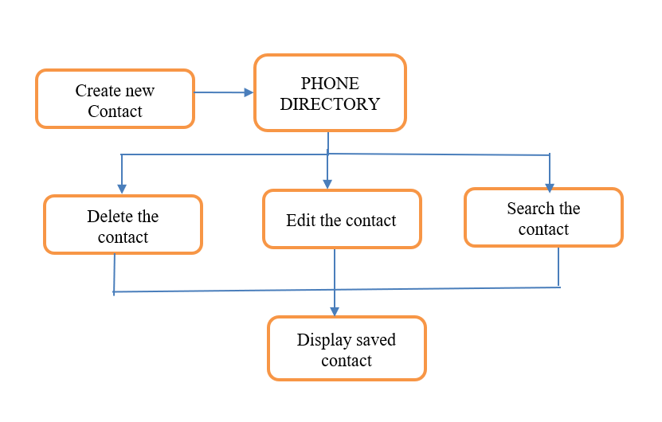

CHAPTER 3
MODULES

Create a new contact

Enables users to first give the name of person and after give the number of the person. Prompt the user for contact information, including full name, phone number. Instantiate a contact object or structure to store the provided information. Allocate memory for a new doubly linked list node, populate it with the contact information, and set next and previous pointers to null. Determine the position in the list (e.g., alphabetical order), update neighboring nodes' pointers, and insert the new node. Update head and tail pointers if necessary.

Display the saved contact

It will display all the saved number and name of the person. Traverse the list in the forward using the next or previous pointers. For each node visited during traversal, retrieve and display the contact information. Include details such as full name, phone number, email. Continue the traversal until reaching the end of the list

Search the contact

It enables the user to enter the name of the person they want and it will show the number. Begin the search process by starting at the head of the doubly linked list, as it allows for efficient traversal in either direction. Traverse the list, comparing the name of each contact with the target name for the search. If a match is found, retrieve and display the corresponding contact information, especially the phone number. Continue the traversal until reaching the end of the list or until a matching contact is found. If the end is reached without a match, indicate to the user that the contact was not found.

Delete Contact

It will delete the save contact. You have to enter the name and it will delete. Begin the deletion process by starting at the head of the doubly linked list, allowing for efficient traversal in either direction.- Traverse the list, comparing the name of each contact with the target name for deletion. If a match is found, proceed to the deletion step. If no match is found, indicate to the user that the contact was not found.- If deleting the head node, update the next node's previous pointer to null and set the head pointer to the next node.- If deleting the tail node, update the previous node's next pointer to null and set the tail pointer to the previous node.- If deleting a node in the middle, update the next pointer of the previous node to the next node, and update the previous pointer of the next node to the previous node.

Edit Contact

It will help to edit the name and number of the person after entering it current name. Begin the editing process by starting at the head of the doubly linked list, facilitating traversal in either direction.- Traverse the list, comparing the name of each contact with the target name for editing. If a match is found, proceed to the editing step. If no match is found, inform the user that the contact was not found.- Allow the user to modify the name and/or phone number of the selected contact. Update the corresponding fields in the doubly linked list node with the edited information.

CHAPTER 4
RESULTS AND DISCUSSION
4.1 Results
4.1.1 Add Contacts
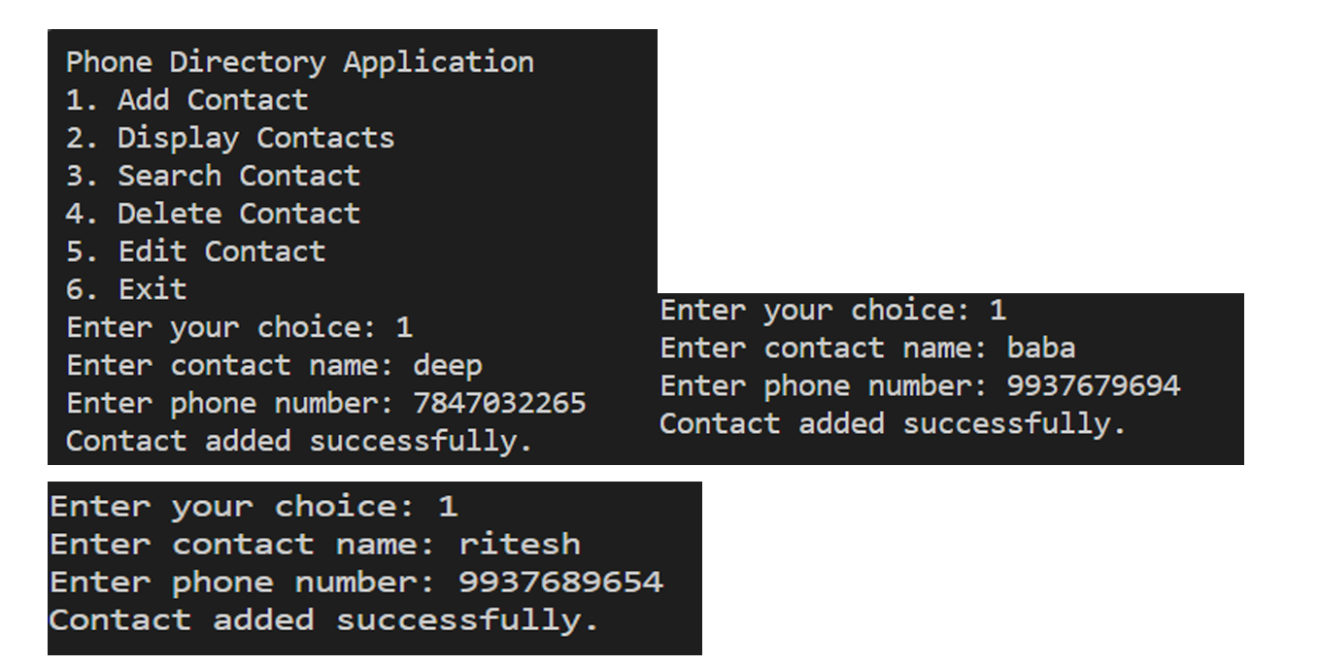
4.1.2 Display Contacts
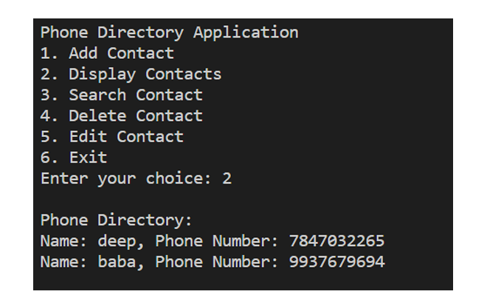

4.1.3 Search Contacts
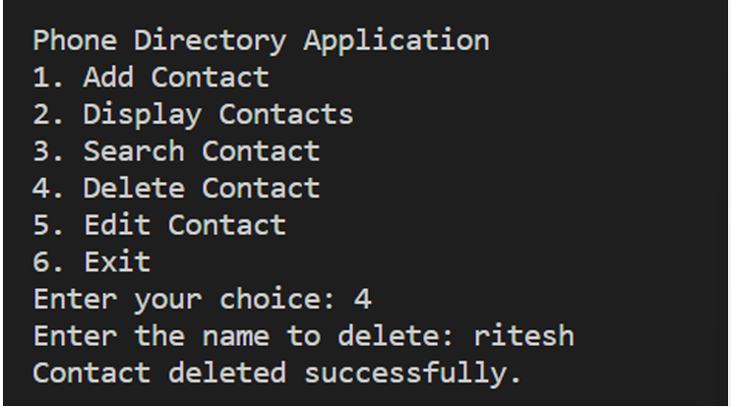

4.1.4 Delete Contacts
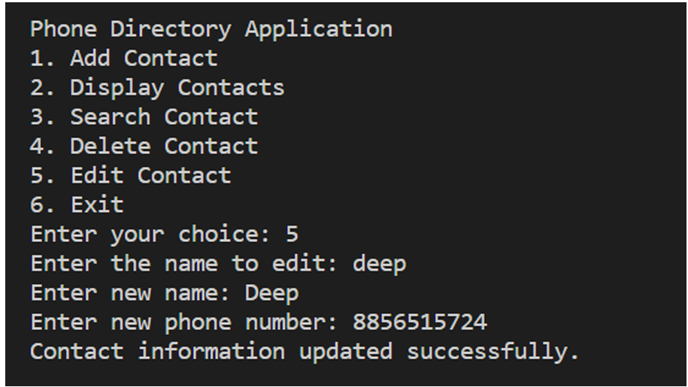

4.2 Discussion
The phone directory application, implemented using a doubly linked list, serves as a practical and dynamic solution for managing contacts efficiently. The choice of a doubly linked list allows for seamless insertion, deletion, and bidirectional traversal, essential for a user-friendly contact management system. The application encompasses key functionalities, including adding, updating, and deleting contacts, ensuring the integrity of the contact directory. Exception handling enhances the robustness of the system by addressing unforeseen errors, preventing runtime failures, and enabling graceful recovery. The user interface provides a clear and intuitive experience, displaying contact information and allowing users to search, edit, and delete contacts seamlessly. This project not only showcases proficiency in data structure implementation but also emphasizes the importance of user-centric design and exception handling for creating a reliable and user-friendly phone directory application.

CHAPTER 5
CONCLUSION

In conclusion, the development of the phone directory application using a doubly linked list has proven to be a successful endeavor, showcasing the effective utilization of data structures to create a versatile and user-friendly contact management system. The choice of a doubly linked list offers inherent advantages, enabling dynamic operations such as insertion and deletion with efficiency. The application's functionalities, including adding, updating, and deleting contacts, fulfill the essential requirements of a comprehensive contact directory. Exception handling mechanisms enhance the robustness of the system, addressing potential errors and ensuring a stable user experience. The user interface, designed for clarity and ease of use, allows for seamless interaction with the contact directory. By incorporating features such as search and edit functionalities, the application provides a well-rounded solution for managing contacts. This project not only demonstrates technical proficiency in data structure implementation but also emphasizes the importance of user-centric design and error management, contributing to the creation of a reliable, adaptable, and user-friendly phone directory application
REFERENCES

- On the Use of Model Checking for the Bounded and Unbounded Verification of Nonblocking Concurrent Data Structures | ScienceGate
- c - Creating a phonebook using linked list and file operations - Stack Overflow
- phone-directory/Datastructureprojcet.pdf at main · clonerplus/phone-directory · GitHub

APPENDIX

#include <stdio.h>
#include <stdlib.h>
#include <string.h>
// Structure to represent a contact typedef
struct Contact
{
char name[50];
char phoneNumber[15];
struct Contact* next;
struct Contact* prev;
} Contact;

// Function to create a new contact Contact* createContact(const char* name, const char* phoneNumber)
{
Contact* newContact = (Contact*)malloc(sizeof(Contact));
if (newContact != NULL)
{
strcpy(newContact->name, name);
strcpy(newContact->phoneNumber, phoneNumber);
newContact->next = NULL;
newContact->prev = NULL;
}
return newContact;
}

// Function to insert a contact into the phone directory void insertContact(Contact** head, const char* name, const char* phoneNumber)
{
Contact* newContact = createContact(name, phoneNumber);
if (newContact == NULL)
{
printf("Memory allocation failed.\n");
return;
}
if (*head == NULL)
{ // List is empty
*head = newContact;
}
else
{
// Insert at the end
Contact* temp = *head;
while (temp->next != NULL)
{
temp = temp->next;
}
temp->next = newContact;
newContact->prev = temp;
}
printf("Contact added successfully.\n");
}

// Function to display all contacts in the phone directory
void displayContacts(Contact* head)
{ printf("\nPhone Directory:\n");
while (head != NULL)
{
printf("Name: %s, Phone Number: %s\n", head->name, head->phoneNumber); head = head->next;
} printf("\n");
}
// Function to search for a contact by name
Contact* searchContact(Contact* head, const char* name)
{
while (head != NULL)
{
if (strcmp(head->name, name) == 0)
{
return head;
// Contact found
}
head = head->next;
}
return NULL;
// Contact not found
}

int main()
{
Contact* phoneDirectory = NULL;
// Menu-driven phone directory application
int choice;
char name[50];
char phoneNumber[15];
do {
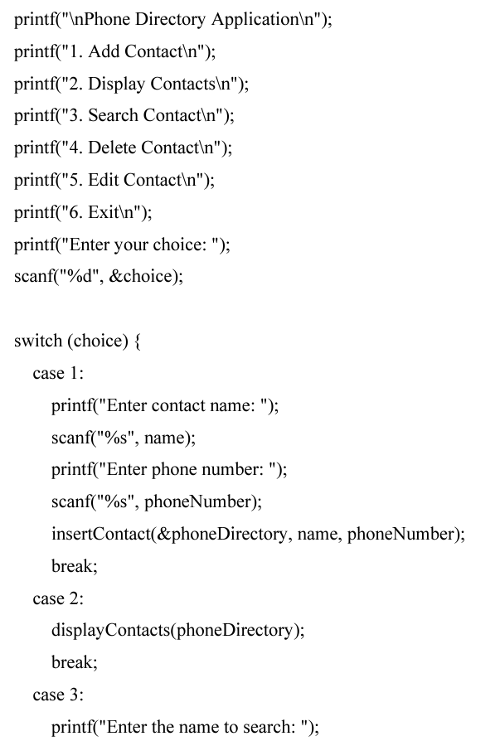
scanf("%s", name);
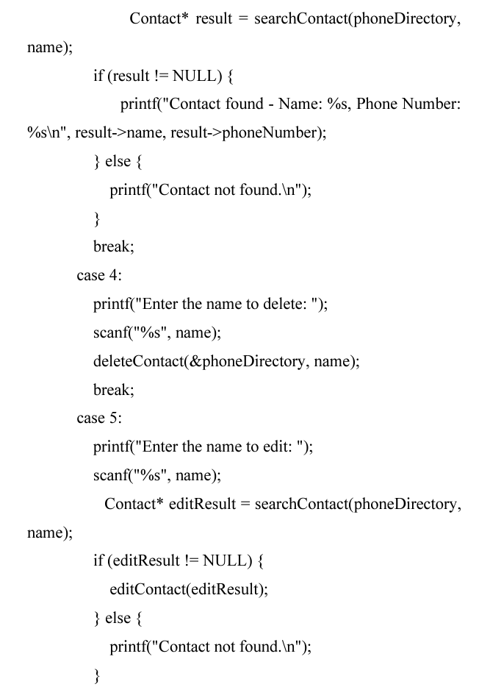
break;
